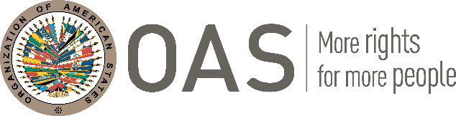

EXECUTIVE SECRETARIAT FOR INTEGRAL DEVELOPMENT (SEDI)

Virtual Training Program

“BRANDING AND DIGITAL MARKETING ACCELERATOR FOR CREATIVE ENTREPRENEURS”

The Executive Secretariat for Integral Development of the Organization of American States (OAS-SEDI) is pleased to announce a virtual training program “Branding and Digital Marketing Accelerator” targeting SMEs in the Creative and Cultural Industries of OAS Member States across the Caribbean. The program is part of SEDI’s mandate to provide technical support to foster entrepreneurship and the growth and development of the creative sector.

The program will be held online between November 28 and December 14, 2023.

15 credit hours on Tuesdays: 6:00 pm – 8:30pm (5:00pm – 7:30pm JA time) and Thursdays 6:00pm – 8:30pm (5:00pm – 7:30pm JA time).

Dates of the training: November 28, 30, December 5, 7, 12, 14, 2023

Please send completed application to Sobers Esprit sesprit@oas.org cc cparga@oas.org by November 24, 2023

APPLICATION FORM

- Name of Participant:

- Male: Female: Prefer not to include:

- Age:

- Physical Address:

- Email:
- Mobile telephone number:

- Name of your organization, if any:

- What area of the creative/cultural industries are you involved or interested in?

- How long have you been involved in the creative/cultural industries?

- Please provide a brief description of your work:

- I confirm that I can participate for the duration of the training and commit to attend all the sessions:
Yes: No:

- I confirm that I can commit to deliver virtual presentations, using digital tools to submit
assignments:
Yes: No:

- I confirm that I am prepared to work with groups for submission of assignments to submit in a timely manner.
Yes: No:

